Unit 3: Lesson 18
Managing Our Feelings

Goal: To learn that the social and emotional positive action of managing our feelings helps us feel good about ourselves.

STORY:
What if you were on a highway with no road signs, no landmarks, and no features? What if you had no road map, and no traffic signs? How would you know where you were headed? Or where you had been? Or where you were right now?
Feelings or emotions are the road signs of our lives. They let us know when our road is straight and smooth, and they alert us when we’re heading for a curve. Feelings or emotions are signals that let us know what’s happening inside of us.

In Unit 1 we talked about feelings about ourselves in the Thoughts-Actions-Feelings Circle. We learned that actions lead to feelings about ourselves. We saw that these feelings about ourselves form our self-concepts. Then we followed the circle on around and learned that our feelings about ourselves lead us to another thought.
As human beings we have feelings not only about ourselves, but we have feelings about a lot of other things, too. We cherish our children. We become angry when things are unfair.
We feel frustrated when things won’t work and discouraged when they don’t go as planned. We experience all kinds of feelings or emotions.
Emotions such as love, gratefulness, anger, worry, jealousy, pride, fear, loneliness, frustration, and discouragement are natural emotions. They are a valuable part of being human. Emotions are spontaneous. They are triggered by something that happens or by an experience that affects us deeply. It’s important to allow ourselves to feel our emotions and not to hide from or repress them. And it’s even more important to express them in an appropriate way.

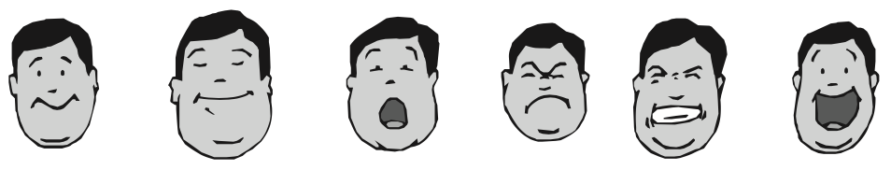
Because emotions are spontaneous, we might think that they can’t be managed. But since we can choose how to think about them before we act on them, we can manage them. Managing our feelings is a positive action that helps us feel good about ourselves. As we think about our emotions, we often choose to act on a thought in response to them. If our action is positive, we feel good about ourselves. If it is not, then we feel negative about ourselves.
All emotions can be managed by following the steps on the graphic below.
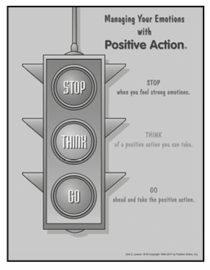
First, we STOP what we are doing when we feel strong emotions. By paying attention to our emotions, we see that they signal or alert us to possible actions we might take.
By stopping, we give ourselves time to THINK. By taking time to think, we can explore the consequences of our possible actions and make sure the action we decide to take is positive.
Then we can GO ahead and do the positive action we decide upon. We should keep the picture of the traffic light in our minds so we can manage our feelings and emotions in positive ways wherever we are.
Having a plan to manage our emotions helps us deal with situations as they come up. We have to think about what we are feeling in order to manage our emotions in an appropriate way. For example, if we are angry, it’s important to express our anger in a way that doesn’t harm anyone else.
Or rather than pacing with worry when someone is late, we can try to find out why he or she is late, get some exercise, or clean a closet or the garage.
Keeping our minds focused on doing positive actions when we are faced with any emotion helps us feel good about ourselves. The positive action for managing any emotion is always the same: Stop, Think, then Go ahead and do a positive action. When we do this, we are managing our emotions in a positive way.
We have a responsibility to ourselves and others to manage ourselves positively. Family members are deeply affected by how we handle our emotions and might even be harmed if we let our negative emotions control us. How we handle our emotions is not a choice for ourselves alone. We must always consider the effect of our emotions on others.
When we mange our emotions so they work for us rather than against us, we become the best we can be and give our best to others. Our goal is to manage all our feelings and emotions in positive ways.
It takes deliberate effort to manage our emotions. But the more we manage our emotions with the traffic-light technique, the easier it will become for us. Strong negative reactions will become less frequent. Positive thoughts and actions will become more automatic. Even when our road has bumps or when we slide on a curve, managing our emotions will keep us from spinning out of control. We can truly come to trust ourselves to act positively every time our emotions are involved. They become signals to think and do something positive. We will feel good about who we are, what we are doing, and how we treat others, which makes us successful and happy. So, it’s time to pay attention to the road signs and traffic signals.
QUESTIONS
- Why is it important to manage our feelings or emotions?
- Where do emotions come from?
- Why can we manage them, even though they are spontaneous?
- What should we do when we feel emotions?
- How does the traffic-light technique help us manage our emotions?
- How does managing our emotions affect self-concept?
- How do you manage your feeling?
- How do you feel about yourself when you manage your emotions positively? When you don’t?
- What emotions could you manage better by using the traffic-light technique?
- What changes are you willing to make?
- How are others affected by the way you manage your emotions?

Look at how you manage your emotions and work out a plan to make improvements. Focus on an emotion that you have difficulty managing in a positive way. Note situations that bring about emotion.
Make a commitment to yourself that you will use the traffic-light technique the next time the emotion comes. Plan positive responses to do instead of your usual reaction.

FAMILY POSITIVE ACTIONS
QUESTIONS:
- Why is it important that we all Stop, Think, then Go when we feel strong emotions?
- What effect do unmanaged emotions have on the family?
- What areas of family life could we improve by managing our emotions more positively?
- How can we help one another manage our emotions positively?
- What positive actions could we take to manage love in positive ways? Gratefulness? Anger? Worry? Jealousy? Pride? Fear? Loneliness? Frustration? Discouragement?
Let’s make a family plan to practice the positive action of managing or emotions?
We’ll begin by listing our ideas for managing each of the emotions we discussed in the last question.
For instance, “How to manage worry” could include doing a positive action while waiting, talking things over with someone, analyzing the situation, and asking ourselves what’s the worst that can happen.
Now that we are finished, we’ll place the lists where everyone can refer to them this week. The lists will remind us how to manage each emotion in a positive way.
parent positive action
Ask Yourself: How do you manage the emotions that you experience as a parent? How do your responses to these emotions make you feel about yourself? How could you manage your emotions more positively? What changes are you willing to make? How can you help your children manage their emotions? What are some ways that you express the love and gratitude you feel for your family?
Plan and Do: This week select a feeling you would like to manage more positively in regard to each of your children. Each time you feel that emotion beginning inside of you, think of the Positive Action traffic light. Stop yourself and Think of a positive action you can do. Then GO ahead and take your positive action.

COMMUNITY POSITIVE ACTIONS
Let’s practice the positive action of managing our feelings in our community by using the traffic-light technique. Next time you attend a community function or hear of a community situation that created strong emotions in you, remember to use the traffic-light technique. Next time you attend a community function or hear of a community situation that creates strong emotions in you, remember to use the traffic-light technique. Stop and Think of a positive action you could do to improve the situation. Then Go do the positive action for the benefit of our community.
SUMMARY
We all experience all kinds of feelings or emotions. They tell us what’s happening on the inside of us. They’re like road signs in our lives. How we read them can make a difference in our lives, and how we manage our emotions definitely affects how we feel about ourselves.
Emotions are a natural part of us that we need to express rather than repress. But we need to manage our emotions instead of just reacting to them. When we manage our emotions so we act in positive ways, we feel good about ourselves, and others benefit, too. But when we express our emotions with negative actions, we frequently affect those around us in negative ways. We also feel bad about ourselves and our own self-concepts suffer.
Having a plan for managing our feelings helps us to deal with them in positive ways. Remembering the steps in the traffic-light plan can help with that. Stop what we are doing, give ourselves time to Think, and then Go do a positive action.

Word of the Week: Feelings
Emotions such as anger, fear, love, and worry.

